ARTIFICIAL INTELLIGENCE LAB – LAB 2
Intelligent Agents and the PEAS Framework
Name: Abdul Raheem
Roll Number: 041

Task 1: PEAS Specifications
Create separate PEAS specifications for a delivery robot and an LLM-based student-support agent. PEAS stands for Performance Measure, Environment, Actuators and Sensors.

1.1 Delivery Robot
PEAS Component | Description
Performance Measure | 1. Deliver packages on time.  2. Avoid accidents and keep people safe.  3. Deliver packages to the correct location.  4. Minimize battery usage.
Environment | 1. Campus roads and pathways.  2. Students, teachers and pedestrians.  3. Buildings and delivery locations.  4. Obstacles, such as vehicles and walls.
Actuators | 1. Motors to move forward, backward and turn.  2. Brakes to stop the robot.  3. Robotic compartment lock to release packages.  4. Speaker or display to notify the recipient.
Sensors | 1. Camera to detect people and obstacles.  2. GPS or campus localization system to determine location.  3. Distance sensors to measure nearby obstacles.  4. Battery sensor to monitor battery level.

Constraint and Performance Trade-off
The robot must deliver packages quickly, but safety is more important than speed. It should slow down or stop when a pedestrian crosses its path, even if this causes a delay.

Operational Assumptions
- The robot operates on a campus with mapped pathways.
- It has access to cameras, distance sensors and a navigation system.
- It can access delivery addresses and package information.
- It must stop or request assistance if it encounters an unsafe or unfamiliar situation.

1.2 LLM-Based Student-Support Agent
PEAS Component | Description
Performance Measure | 1. Provide correct and helpful answers.  2. Respond in simple language.  3. Answer students' questions quickly.  4. Protect student privacy and avoid unsupported answers.
Environment | 1. Students asking questions.  2. University courses and study materials.  3. Learning Management System (LMS).  4. University rules, deadlines and academic resources.
Actuators | 1. Generate text responses.  2. Ask follow-up questions.  3. Retrieve relevant study materials using available tools.  4. Refer students to a teacher or administrator when necessary.
Sensors | 1. Student text prompts.  2. Uploaded notes and documents.  3. Course information retrieved through authorized tools.  4. Student feedback and conversation context.

Constraint and Performance Trade-off
The agent should answer quickly, but accuracy is more important than speed. If it does not have enough information, it should acknowledge uncertainty instead of giving an incorrect answer.

Operational Assumptions
- The agent uses a Large Language Model (LLM) to understand questions and generate responses.
- It can access course documents and university information only when authorized tools are available.
- It may use an approved document-search tool or LMS connection if provided.
- It cannot access private student records or external systems without permission.
- If reliable information is unavailable, it should ask for clarification or refer the student to a teacher.

1.3 Comparison of Both Agents
Feature | Delivery Robot | LLM Student-Support Agent
Main goal | Deliver packages safely | Help students with academic questions
Inputs | Camera, GPS and distance readings | Student prompts and authorized documents
Actions | Move, stop, turn and release packages | Answer, ask questions and retrieve information
Main risk | Collision or incorrect delivery | Incorrect or unsupported information
Important constraint | Physical safety | Accuracy and privacy

Task 2: Environment Classification
Classify both systems as fully or partially observable and deterministic or stochastic. The classifications below describe realistic environments and then compare them with simplified simulators.

2.1 Delivery Robot
Classification | Answer | Justification
Observability | Partially Observable | The robot's sensors cannot detect every detail. For example, a camera may not detect an obstacle hidden behind another object.
Uncertainty | Stochastic | Outcomes may be uncertain because pedestrians can move unexpectedly and sensor readings may contain errors.

Observable and Hidden Variables
Observable: robot location, detected obstacles and battery level.
Hidden: pedestrian intentions, obstacles outside the camera's view and unexpected pathway changes.

Predictable and Uncertain Outcomes
Predictable: the motor moves the robot forward under normal operating conditions.
Uncertain: a pedestrian suddenly crosses the robot's path, forcing it to stop.

2.2 LLM-Based Student-Support Agent
Classification | Answer | Justification
Observability | Partially Observable | The agent can read the student's question and available documents, but may not know the student's full understanding, intentions or all relevant university information.
Uncertainty | Stochastic | The LLM may generate different responses to similar questions, and retrieved information may be incomplete or ambiguous.

Observable and Hidden Variables
Observable: student's written question, uploaded notes and information returned by authorized tools.
Hidden: student's actual understanding, unstated requirements and information unavailable to the agent.

Predictable and Uncertain Outcomes
Predictable: when a valid document-search tool returns a known result, the agent can use that result.
Uncertain: the LLM may misunderstand an ambiguous question or provide an unsupported answer.

2.3 Real Environment vs. Simplified Simulator
System | Real Environment | Simplified Simulator
Delivery Robot | Partially observable and stochastic because of moving people, sensor errors and unexpected obstacles. | Can be fully observable and deterministic if all states are visible and every action has a fixed outcome.
LLM Student-Support Agent | Partially observable and stochastic because information may be missing and generated responses may vary. | Can be fully observable and deterministic if inputs, information sources and responses are fixed.

These classifications depend on the model boundary and assumptions. A simplified simulator does not necessarily represent all uncertainty in the real environment.

Task 3: Stateful Classroom Agent
Task requirement: Extend the provided classroom agent to remember the previous target mode and avoid repeating identical control commands. Keep the existing temperature thresholds and occupancy priority. The program should return the previous mode, target mode and whether a command should be sent.

3.1 Test Cases
Step | Percept | Target Mode | Command Result
1 | (29, True) | COOL | SEND — first target
2 | (29, True) | COOL | NO — duplicate avoided
3 | (20, True) | IDLE | SEND — target changes at lower boundary
4 | (26, True) | IDLE | NO — target unchanged at upper boundary
5 | (19, True) | WARM | SEND — target changes
6 | (29, False) | ECO | SEND — empty-room priority
7 | (29, False) | ECO | NO — duplicate avoided

3.2 Code Screenshot
The screenshot below shows the Python implementation and the percept test cases.
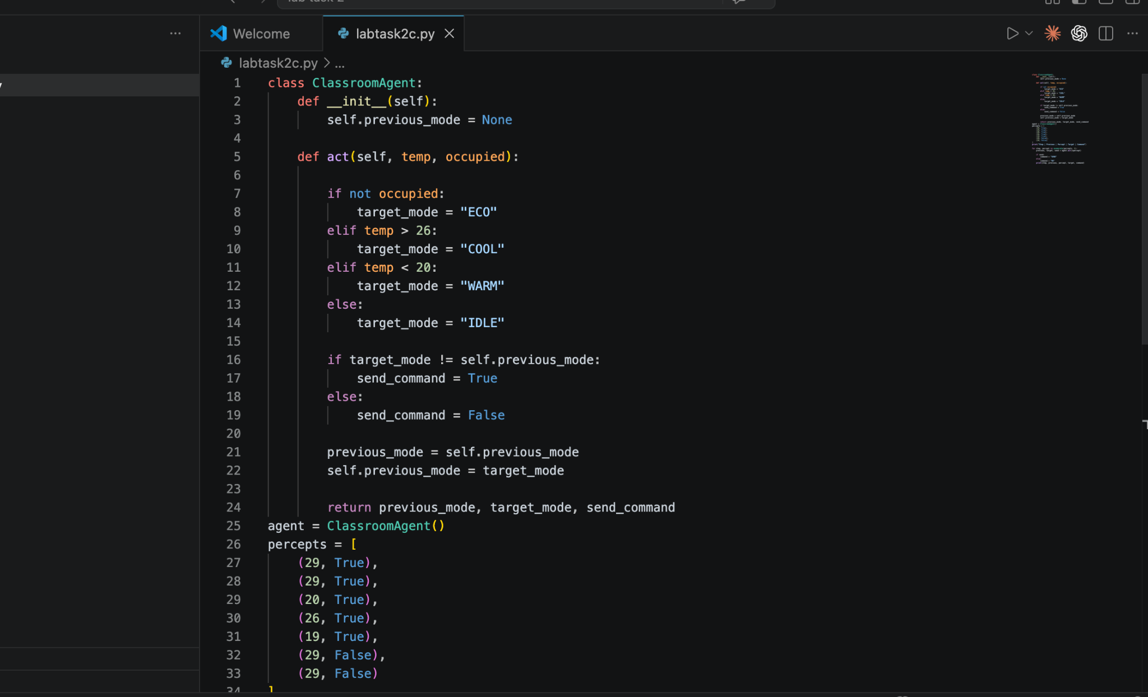
Figure 1: ClassroomAgent code in VS Code.

3.3 Execution Output Screenshot
The terminal output shows the results of all seven test cases.
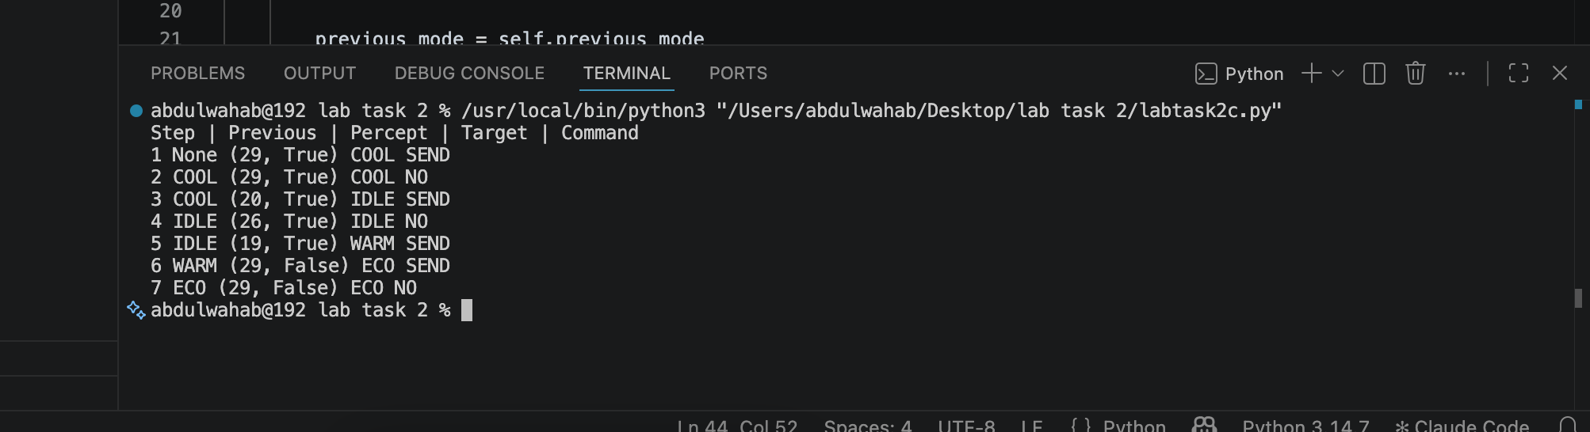
Figure 2: Successful execution output in the VS Code terminal.

3.4 Interpretation and Limitation
The output shows that the agent sends a command when the target mode changes and avoids repeating the same command when the target remains unchanged. At exactly 20°C and 26°C, an occupied room selects IDLE because the conditions use temp < 20 and temp > 26. When the room is empty, ECO has priority over temperature.
Limitation: the agent remembers the previous mode but does not learn from data or implement hysteresis. Temperature fluctuations near a threshold may cause mode changes. Hysteresis or sensor-noise filtering could improve this. The code uses simulated mode labels and does not control real hardware.

Conclusion
PEAS defines an agent's performance measure, environment, actuators and sensors. The delivery robot prioritizes safe package delivery, while the LLM-based student-support agent prioritizes accurate and responsible academic help. The classroom agent demonstrates a stateful policy by remembering its previous target mode and avoiding duplicate commands.

